**SIMPLE COMBINATION LOCK**

**Members:**

2020-CS-120 (Ahmed Arshad)

2020-CS-138 (Fatima)

2020-CS-144 (Faraz Ahmad)

2020-CS-146 (Mahnoor Shad)

**Idea:**

This experiment may be built using only one 8-position DIP switch, but two switch assemblies are used. The idea is one switch acts to hold the correct code for unlocking the lock, while the other switch serves as a data entry point for the person trying to open the lock.

**Overview:**

* **Significance:**

In real life the switch assembly with the “key” code set on it must be hidden from the sight of the person opening the lock, which means it must be physically located elsewhere from where the data entry switch assembly is. This requires two switch assemblies.

* **Description:**

To use XOR gates as bit comparators

To build simple gate functions with diodes and a pull-up/down resistor

Using NOR gates as controlled inverters

* **Background:**

Locks are designed to provide a greater level of protection against the primary methods of attack that are employed by criminals. The harder you make it for a burglar to enter, the less likely a break-in will occur. When you decide to keep your home always locked up, you are making a strong effort to protect your family, self, valuables, and privacy.

**Problem Statement:**

Security locks are designed to provide a greater level of protection against the primary methods of attack that are employed by criminals.

**Schematic Diagram:**

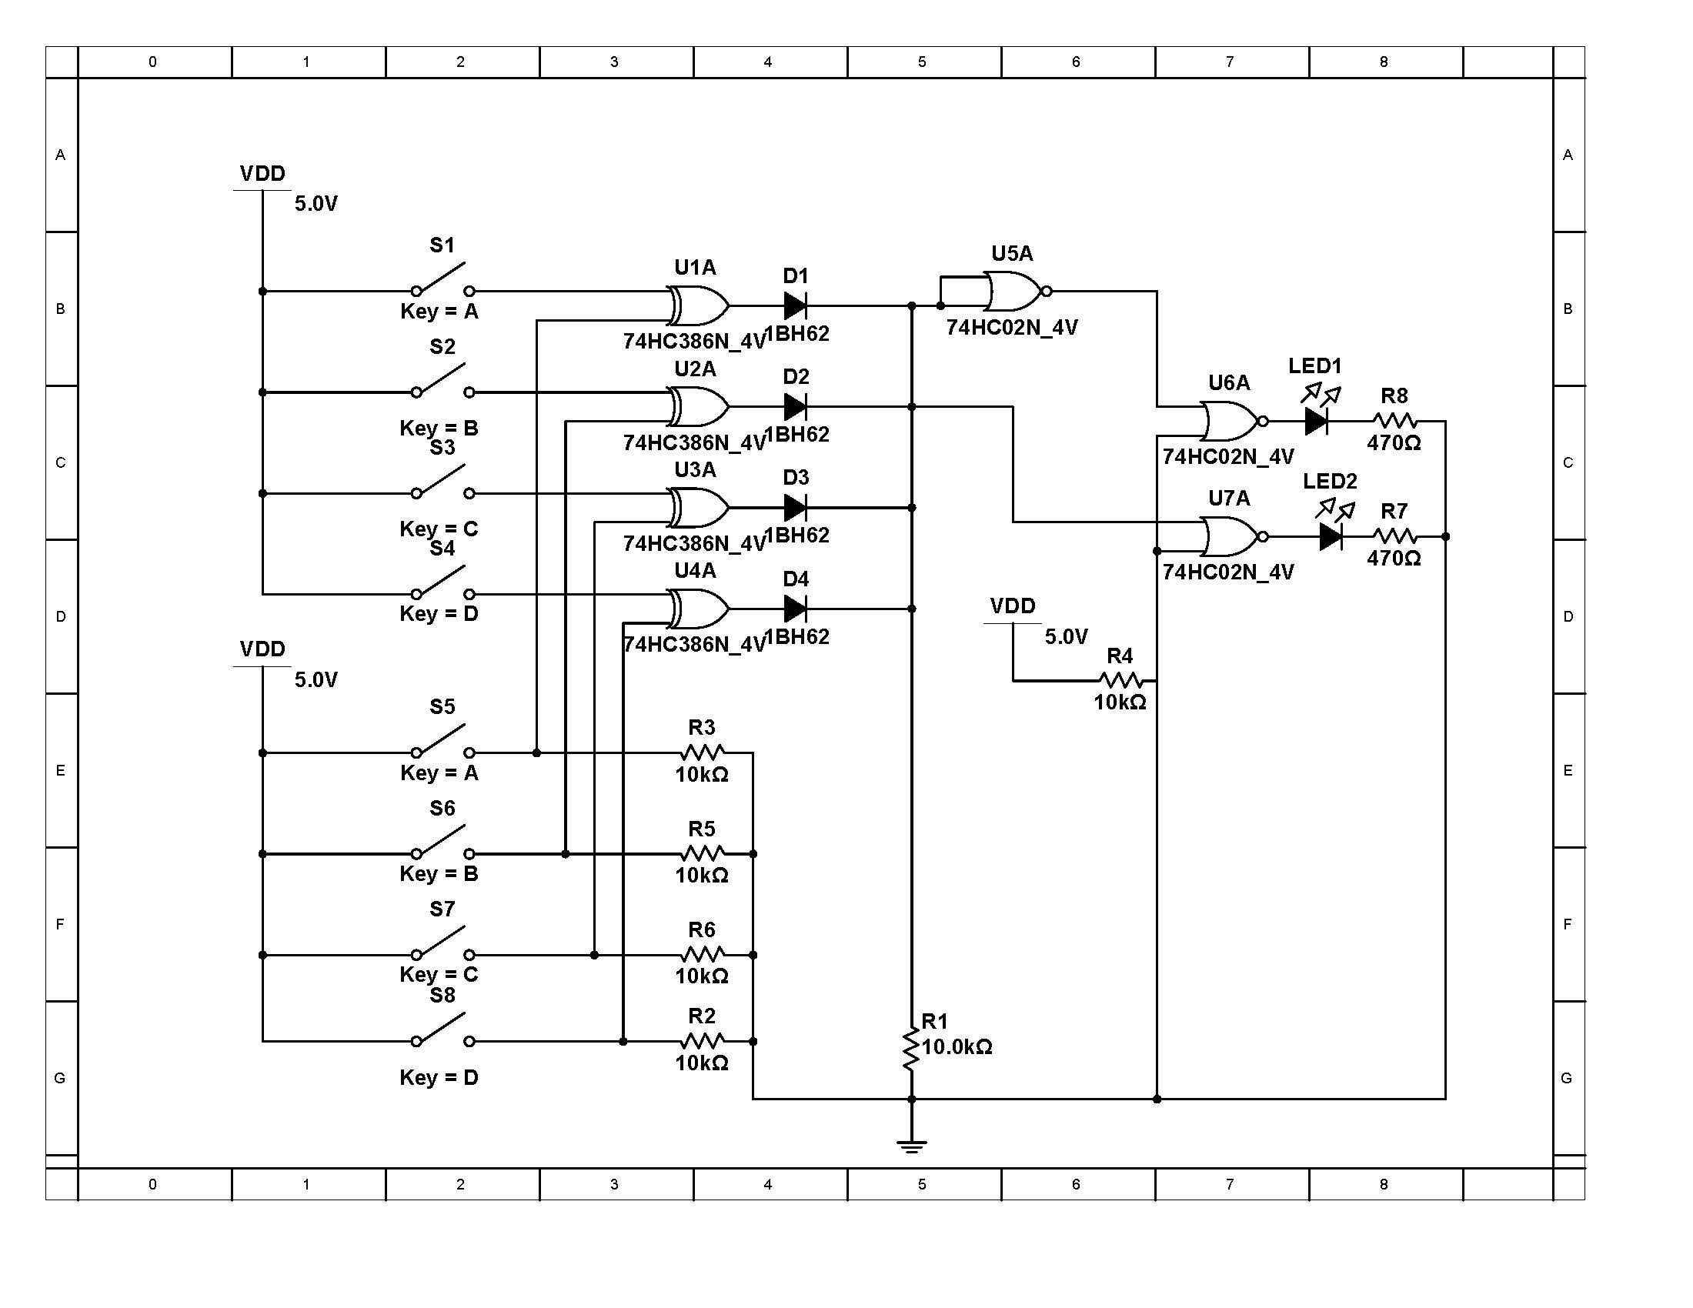

**Implementing above Logic on Arduino**

**Arduino based RFID door lock system:**

What is RFID and how does it work?

RFID is defined as Radio Frequency Identification. The digital data is encoded and saved into the RFID tags. The data in the RFID tags are read using RFID readers using Radio waves.

The key DIP switches will be replaced with UID saved in memory and Data entry switch will be replaced with a RFID card and reader.

**RFID Door lock system Circuit:**

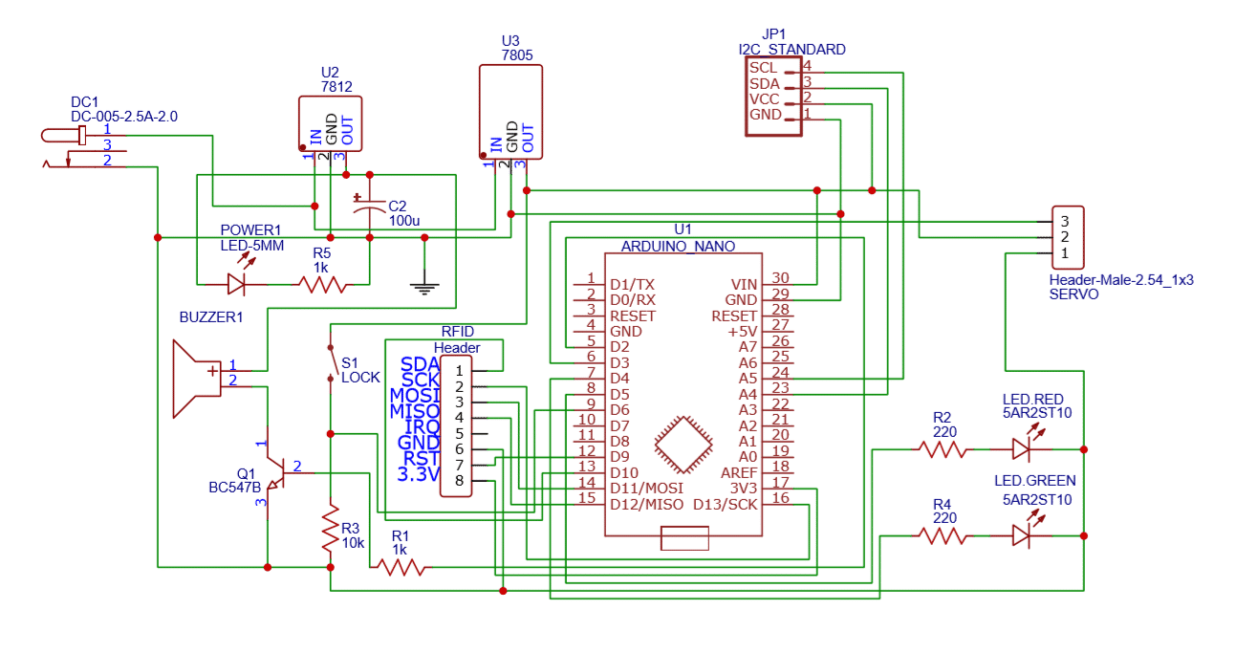

**Arduino Code:**

#include <MFRC522.h>

#include <LCD_I2C.h>

#include <SPI.h>

#include <Servo.h>

//LCD INITIALISED

LCD_I2C lcd(0x27); // Default address of most PCF8574 modules, change accordingly.

//RFID

MFRC522 mfrc522(10, 9);

int MasterCounter = 0;

//SERVO

Servo myservo;

int dooropen = 10;

int doorlocked = 140;

void setup()

{

//LCD

lcd.begin(); // If you are using more I2C devices using the Wire library use lcd.begin(false)

// this stop the library(LCD_I2C) from calling Wire.begin()

lcd.clear();

lcd.backlight();

Serial.begin(9600);

SPI.begin();

myservo.attach(8);

myservo.write(doorlocked);

mfrc522.PCD_Init();

Serial.println("Scan Tag");

}

void loop()

{

if (!mfrc522.PICC_IsNewCardPresent())

{

return;

}

if (!mfrc522.PICC_ReadCardSerial())

{

return;

}

String uid = "";

Serial.print("UID=");

for (int i = 0; i < mfrc522.uid.size; i++)

{

Serial.print(mfrc522.uid.uidByte[i] < 0x10 ? "0" : "");

Serial.print(mfrc522.uid.uidByte[i], HEX);

uid.concat(String(mfrc522.uid.uidByte[i] < 0x10 ? "0" : ""));

uid.concat(String(mfrc522.uid.uidByte[i], HEX));

}

uid.toUpperCase();

if (uid == "0761CFB5")

{

lcd.clear();

lcd.print("Access granted!");

lcd.setCursor(0, 1);

lcd.print("Welcome Faraz");

Serial.println("\n");

Serial.println("Access granted");

myservo.write(dooropen);

Serial.println("Door opened");

}

else

{

Serial.println("Access denied");

}

delay(4000);

myservo.write(doorlocked);

lcd.clear();

Serial.println("Door locked");

return;

}

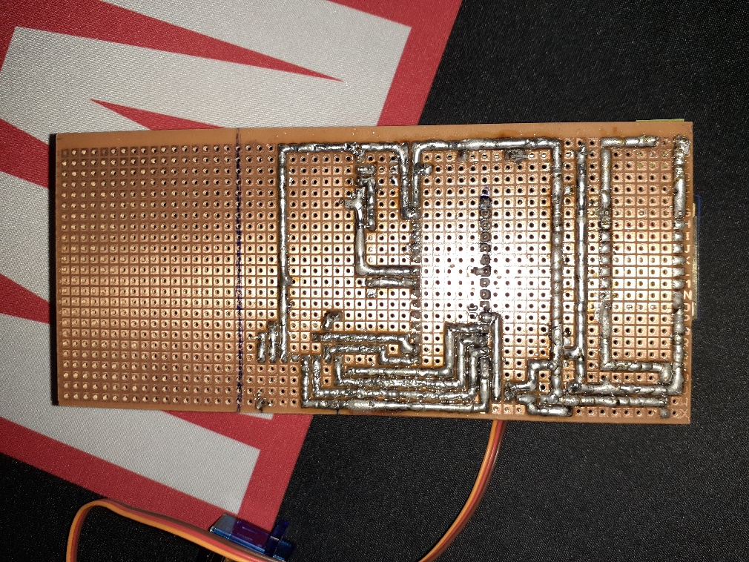**Images of Final Product:**

